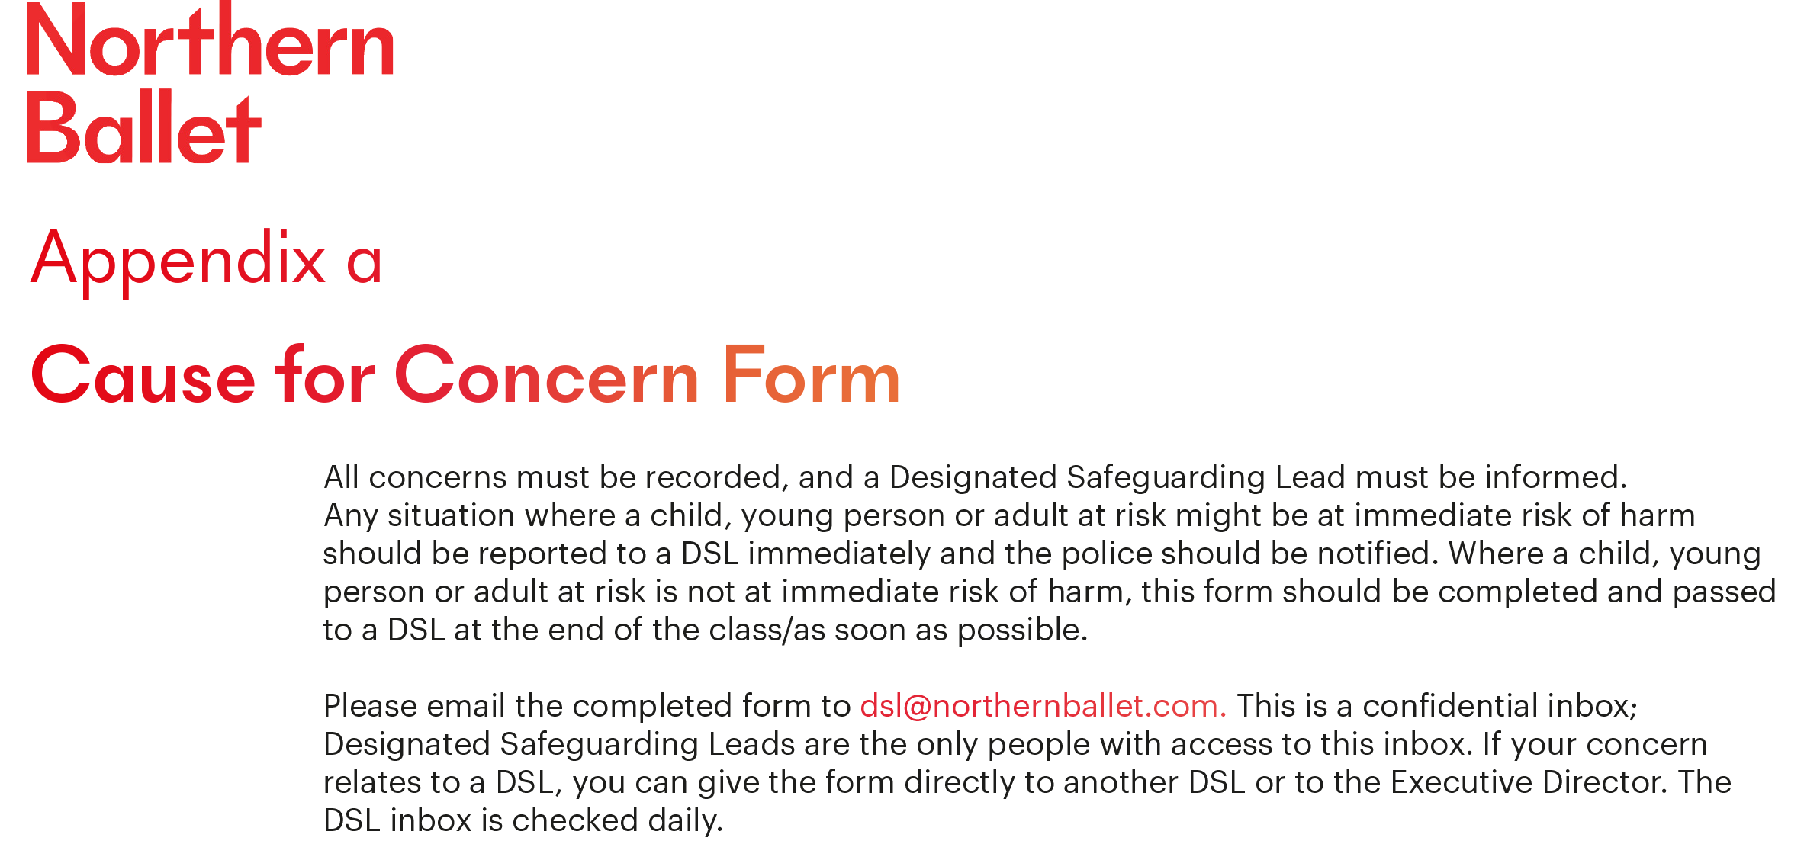
Participant’s name and any support needs: | DoB:  If known | Please state if this relates to a child/adult at risk/staff member:
Date: | Time (of writing this record): | Teacher/Programme Manager at the time of incident:
Name of person completing this form (please print):

Job title in relation to participant:

Reason(s) for recording the incident/concern (headline):

Record the following factually, using the ‘voice of the child/person’ wherever possible: When (date & time of incident or concern arising)? Where did your concerns arise? Who else – were any other children, adults or staff present? What exactly did you see/hear/smell that raised your concern?
Please record any direct disclosures/comments using the person’s exact words in quotation marks.
If there were visible signs of injury/abuse that you witnessed, please use the body map to demonstrate the site of injury, and use this space to explain the nature of the injury.

NB if additional pages are used, these must be attached securely to this form
Body Map completed? Yes/No
Professional opinion:
Your professional opinions, impressions and worries are important. Facts should be recorded in the box above but please record your opinions, impressions and worries here and state what has led you to form them (e.g. something you have noticed, feel or suspect).

Immediate action following the disclosure for the child/adult:
(e.g. went back to lesson, was collected by guardian/carer, went home).

Action taken, including names of everyone spoken to about the incident/concern:

If this was an adult at risk, did you ask their permission to share your concern in writing with the DSL?

For adults at risk: What did the person say they would like to happen next?

Date and time incident/concern was shared with DSL & name of DSL:

Please check to make sure your report is clear; and will be clear to someone else reading it next year
NOW PASS THIS FORM TO YOUR DESIGNATED SAFEGUARDING LEAD FOR COMPLETION OVERLEAF (NB by end of the working day at the latest if the person is not at immediate risk of harm)

BODY MAP
Use the body map to demonstrate where on the body you have witnessed injuries with an x.
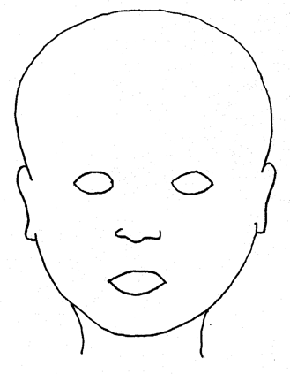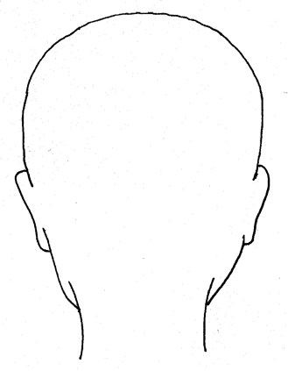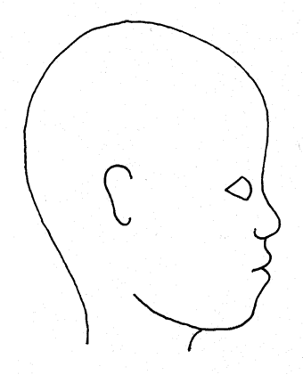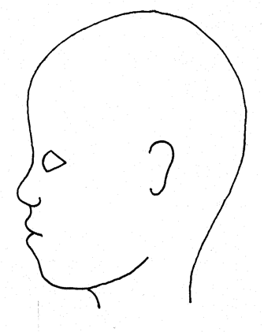

FRONT BACK RIGHT LEFT

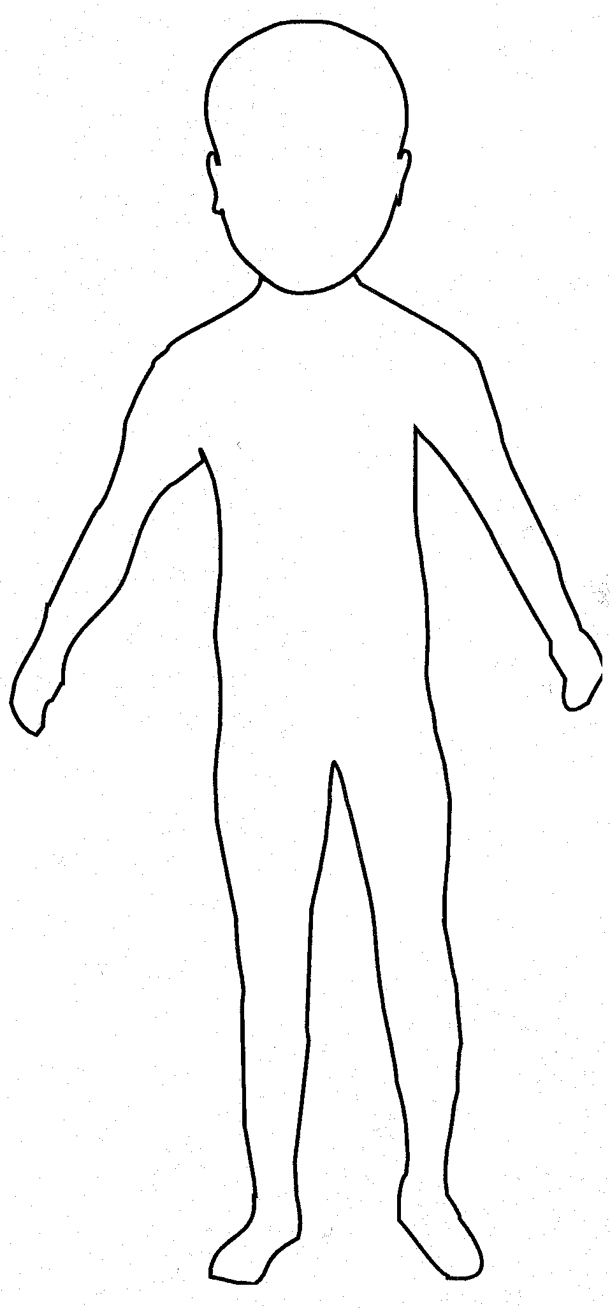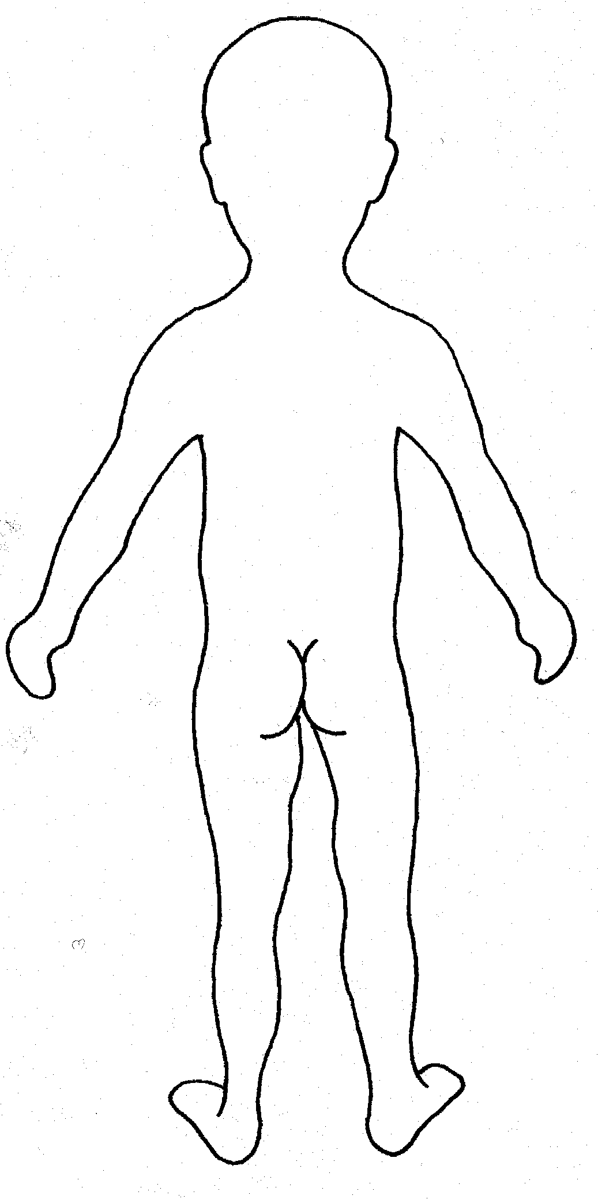

FRONT BACK
Time & date information received by DSL and from whom:
Any advice sought by DSL (date, time, role, organisation & advice given):

DSL’s analysis of presenting issues/concerns and advice received:

Permission granted from Adult at Risk to escalate for further referral? Please state in what form the permission was granted.
Action taken (referral to or consultation with Leeds Safeguarding Partnership). If decision not to refer, please state reason:

Note time/date/names/who information shared with etc.

Outcome:

Include names of individuals/agencies who have given you information regarding outcome of any referral (if made)
Carer/Guardian informed (if applicable)
Yes/no – reason if no:

Where can additional information regarding the child/adult/ incident be found?:
(e.g. personal file, serious incident book)

Signed:

Name:

Date:

Date and time member of staff submitting this form received feedback about action taken from DSL | Date: | Time:
What was shared:

Date and time that a response was given to the child/adult | Date: | Time:
What was shared:

