[Page 1]
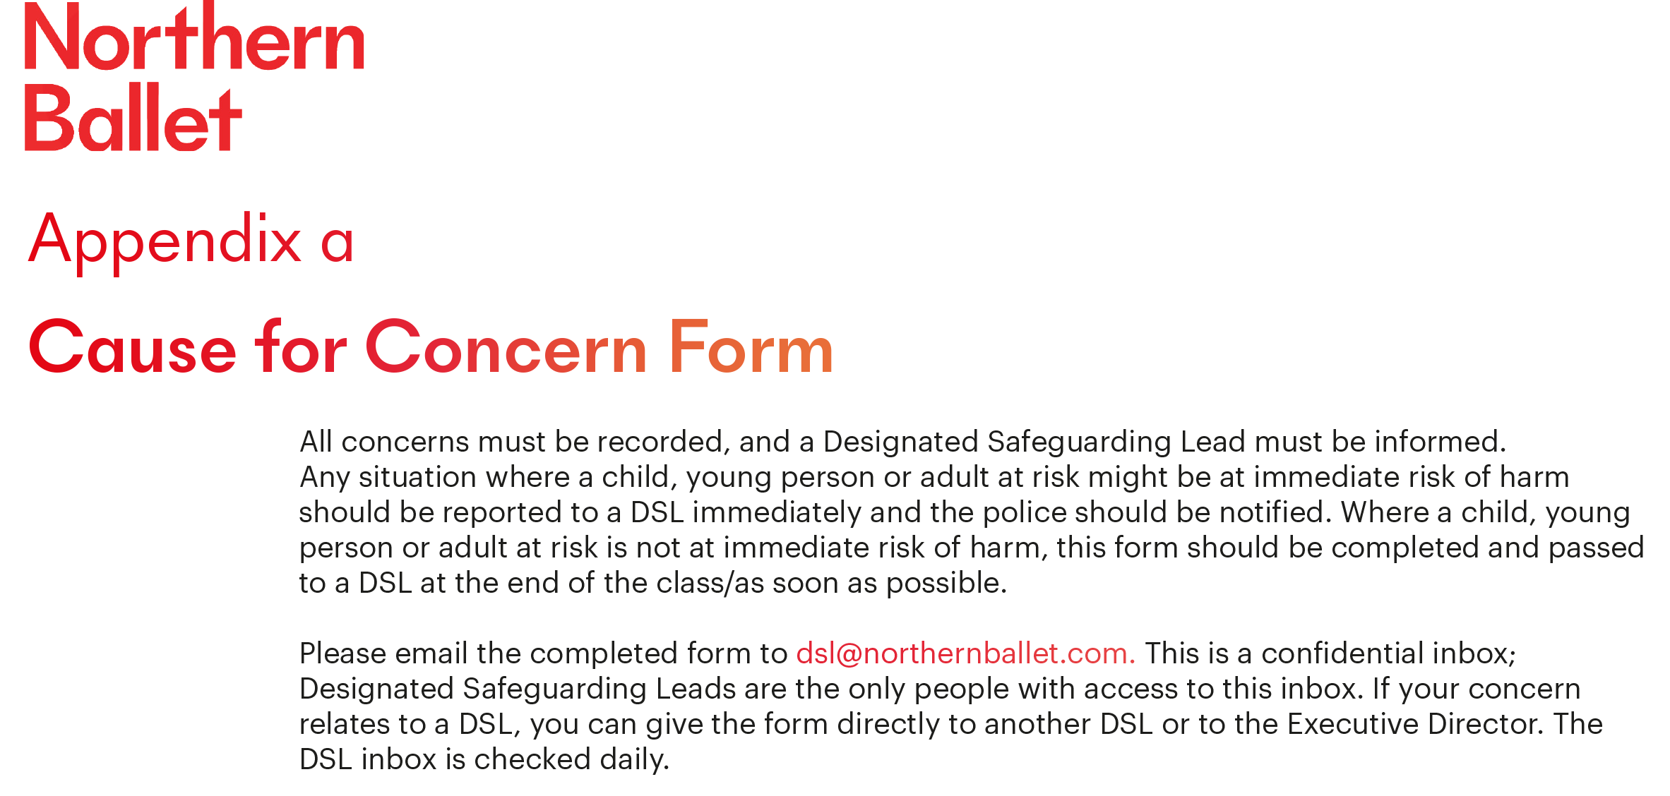
Participant’s name and any support needs: | DoB:  If known | Teacher/Programme Manager at the time of incident:
Date: | Time (of writing this record):
Name of person completing this form (please print):

Job title in relation to participant:

Reason(s) for recording the incident/concern (headline):

Record the following factually: When (date & time of incident or concern arising)? Where did your concerns arise? Who else – were any other children, adults or staff present? What exactly did you see/hear/smell that raised your concern? Please record any direct disclosures/comments using the person’s exact words in quotation marks.

NB if additional pages are used, these must be attached securely to this form
Professional opinion:
Your professional opinions, impressions and worries are important. Facts should be recorded in the box above but please record your opinions, impressions and worries here and state what has led you to form them (e.g. something you have noticed, feel or suspect).

Immediate action following the disclosure for the child/adult:
(e.g. went back to lesson, was collected by guardian/carer, went home).

Action taken, including names of everyone spoken to about the incident/concern:

Name of Designated Safeguarding Lead this form was passed to:

Date and time incident/concern was shared with Designated Safeguarding Lead:

Please check to make sure your report is clear; and will be clear to someone else reading it next year
NOW PASS THIS FORM TO YOUR DESIGNATED SAFEGUARDING LEAD FOR COMPLETION OVERLEAF (NB by end of the working day at the latest if the person is not at immediate risk of harm)

[Page 2]
Time & date information received by DSL and from whom:
Any advice sought by DSL (date, time, role, organisation & advice given):

DSL’s analysis of presenting issues/concerns and advice received:

Action taken (referral to or consultation with Leeds Safeguarding Partnership). If decision not to refer, please state reason:

Note time/date/names/who information shared with etc.

Outcome:

Include names of individuals/agencies who have given you information regarding outcome of any referral (if made)
Carer/Guardian informed (if applicable)
Yes/no – reason if no:

Where can additional information regarding the child/adult/ incident be found?:
(e.g. personal file, serious incident book)

Signed:

Name:

Date:

Date and time member of staff submitting this form received feedback about action taken from DSL | Date: | Time:
What was shared:

Date and time that a response was given to the child/adult | Date: | Time:
What was shared:

