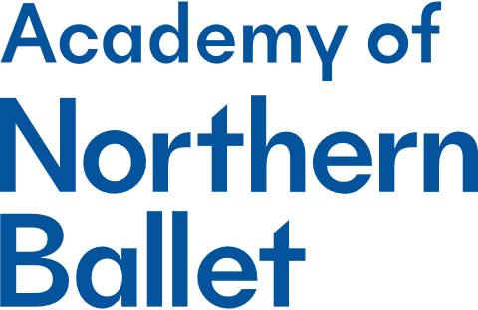

Student Support Team Member (Casual)
Application Questions

Candidate details
Name
Position applied for | Student Support Team Member (Casual)

For office use
Reference
Position applied for | Student Support Team Member (Casual)
Please answer the 4 questions below. Your answers should be succinct, observing the word limit where indicated.
Reflecting on the Job Description and Person Specification tell us how your experience makes you the most suitable candidate for this role. (250 words)
What are the key attributes that you feel you can bring to this role? (250 words)
Northern Ballet is a Disability Confident employer. If you have a long-term condition/disability, and you meet the minimum criteria for the post for which you have applied, we guarantee to offer you an interview. Please may you indicate if you have a long-term condition/disability.
Please submit your application questions, along with your CV and a covering letter, via our portal: https://hr.breathehr.com/v/academy-student-support-team-member-24862

