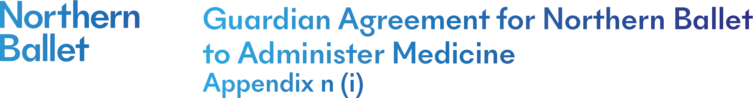
Northern Ballet will not give your child medicine unless you complete and sign this form.
Name of child:___________________________DoB:_________________Class:___________
Medical condition or illness:
Medicine
Name/type of medicine
(as described on container)
Expiry date
Dosage and method
Timing
Special precautions/other instructions
Are there any side effects that Northern Ballet needs to know about?

Self-administration – y/n
Procedures to take in an emergency

Medicines must be in the original container as dispensed by the pharmacy
I understand that medication to be self-administered will be brought to class by my child and kept in their bag in the studio for easy access.
I understand that medication my child needs help administering will be handed to the teacher/programme manager at the beginning of class and returned to my child at the end of class.

Signed:____________________________________ Date: _______________________
(Guardian/carer)
The above information is, to the best of my knowledge, accurate at the time of writing and I give consent to Northern Ballet staff administering medicine in accordance with the Northern Ballet policy. I will inform Northern Ballet immediately, in writing, if there is any change in dosage or frequency of the medicine (medical evidence must be provided).

If applicable, I will collect the medication at the end of the school day from the school office.
Signed: _____________________________________ Date:______________________
(Guardian/carer)
Guardian/carer name:_______________________________________
Telephone number:_________________________________________

